**RECRUITING ASSISTANTS FOR HR MANAGER**

**TEAM PROFILE**

**Team leader : S.KOUSIKA**

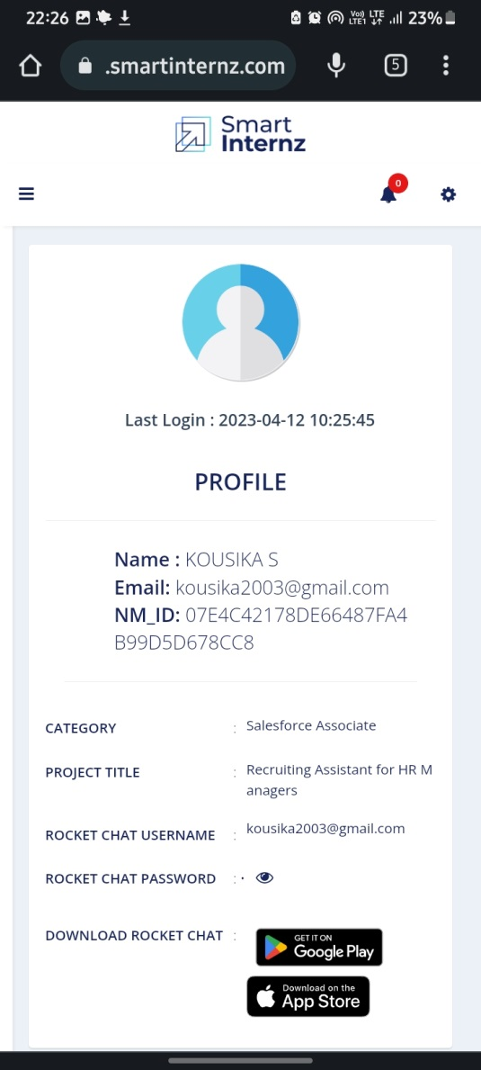

**Team member 1: M.LEELAVATHI**

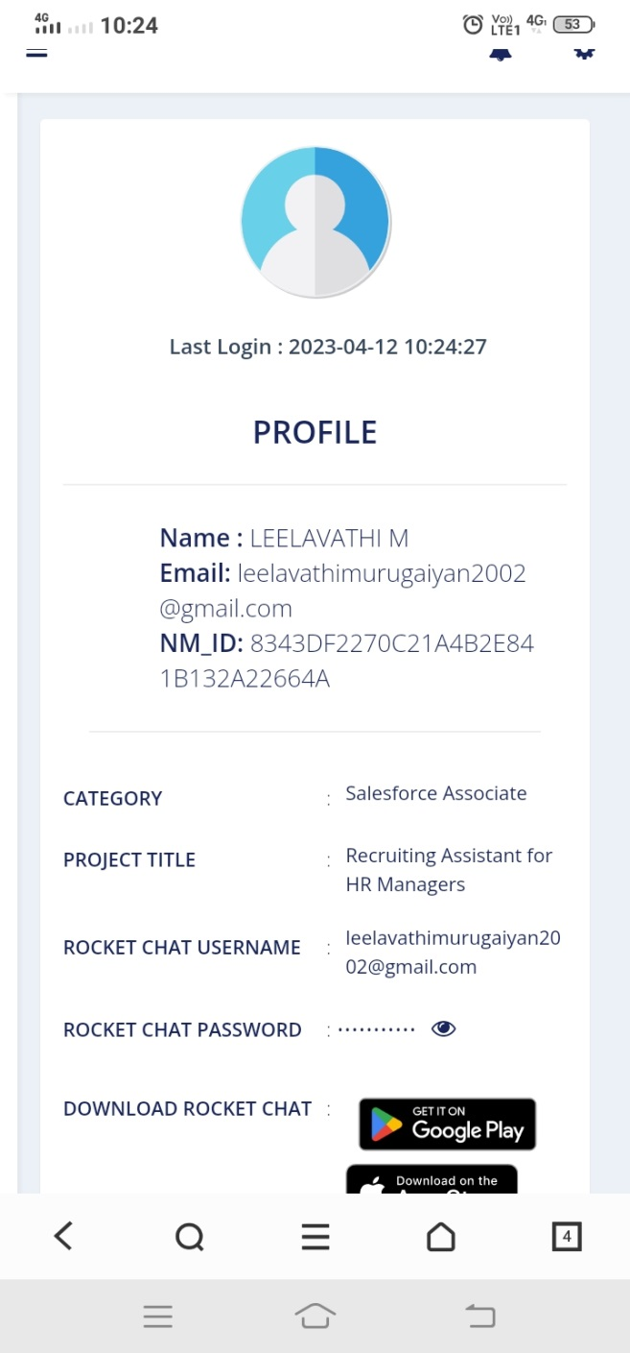

**Team member 2 : S.LITHIKA**

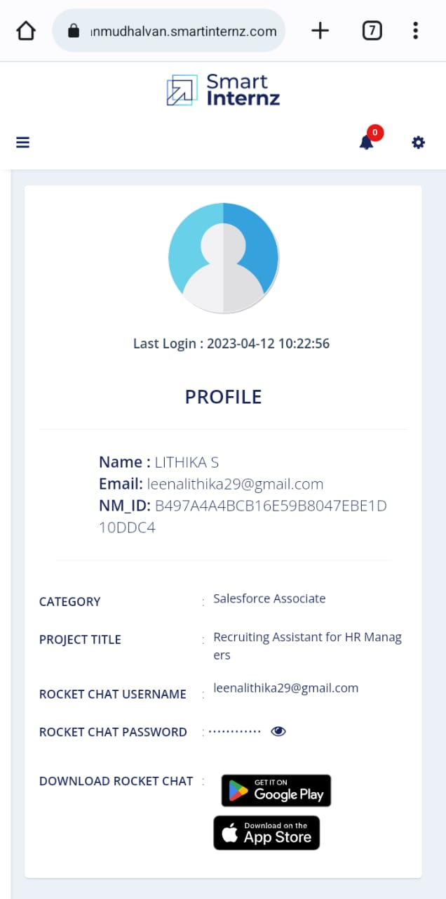

**Team member 3: R.LOGESHWARI**

